File Creation Task

Task 1:
- Create the directory
# mkdir my_folder
- Navigate into it
# cd my_folder
- Create a file with some text
# echo "This is the content of my_file.txt." > my_file.txt
- Create another file with some text
# echo "This is the content of another_file.txt." > another_file.txt
- Concatenate another_file.txt to my_file.txt
# cat another_file.txt >> my_file.txt
- Display the updated content of my_file.txt
# cat my_file.txt
- List all files and directories in the current directory
# ls -la
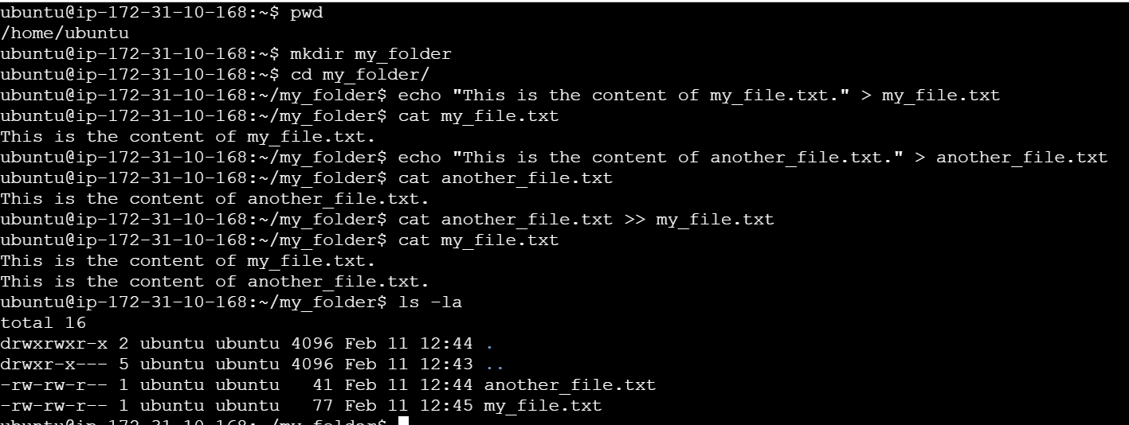

Task 2:
1. Create 20 .txt files
# touch file{1..20}.txt
This command uses shell brace expansion to generate the sequence file1.txt, file2.txt, ..., file20.txt
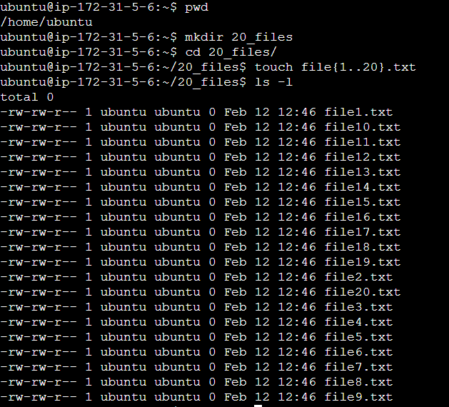

2. Rename the first 5 files to .yml extension
# for file in $(ls | head -n 5); do mv "$file" "${file%.*}.yml"; done
Explanation of the Command -
for file in $(ls | head -n 5): This part creates a loop that iterates over the first 5 files listed by the ls command. head -n 5 selects only the first 5 entries.
do ... done: This defines the actions to be performed within the loop for each file.
mv "$file" "${file%.*}.yml":
mv "$file": The mv command is used to move/rename the current file in the loop.
"${file%.*}.yml":
    - ${file%.*} removes the current file extension (everything after the last dot) from the filename.
    - .yml is then appended as the new extension.

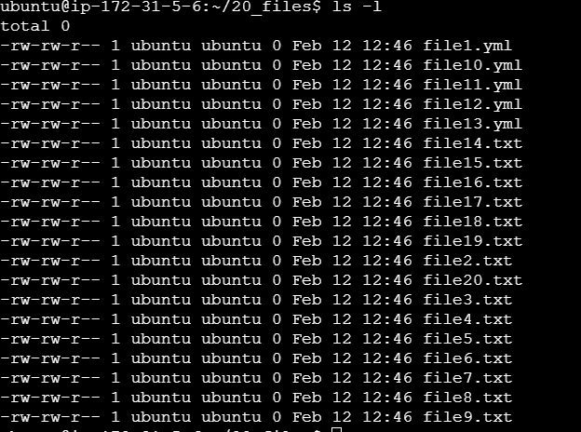
3. Print the latest created top 5 files
# ls | head -n 5
head -n 5 selects only the first 5 entries listed by ls command.
